Q1 Studying the individual attributes in the data

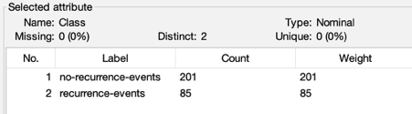
a) Calculating the sum of the three component weights

The class attribute is Nominal (or Categoric). More specifically, it is Binary because it has only two possible values

b) Calculating the sum of the three component weights
Attribute | Value Example | Type | Explanation
Age | 10-19 | Ordered/ Interval | Ranges of age have a natural order.
Menopause | Lt40 | Categoric/ Ordered | Life stages
Tumor-size | 0-4 | Ordered | Sizes has a clear stages
Inv-nodes | 0-2 | Ordered | Number is ordered
Node-caps | Yes | Binary | Two value
Deg-malig | 1 | Numeric/ Ordered | Represents degree of malignancy
Breast | Left | Binary | Two value
Breast-quad | Left_up | Categoric | No strict order
Irradiat | Yes | Binary | Two value

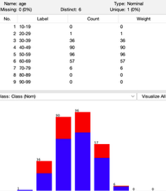
c) Calculating the sum of the three component weights

The distribution best fits a Normal Distribution.

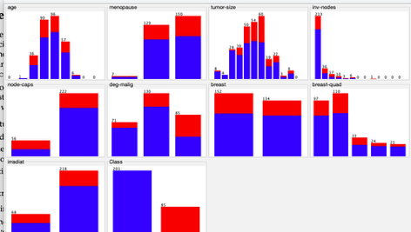
Estimated Parameters
Mean : The distribution is centered around the 50-59 interval. Visually, the mean is approximately 52, slightly lower than the center of 55 due to the skew towards 40-49
Standard Deviation: The majority of the data lies between 30 and 69.

d) Calculating the sum of the three component weights

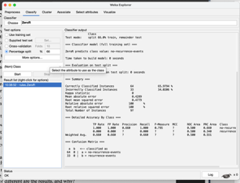
Strongest Dependence: dego-malig / Strong Dependence: inv-nodes
Independence: breast

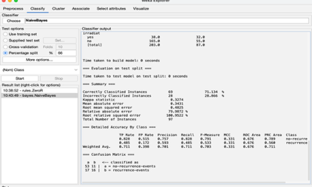
Q2 Building Classifiers

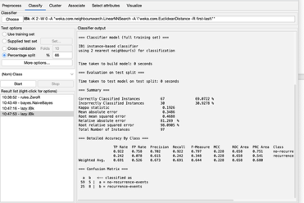
a) Zeror)
Accuracy: The accuracy is 65.98%
Model: The model predicts the major class value that is “no-recurrence-events”

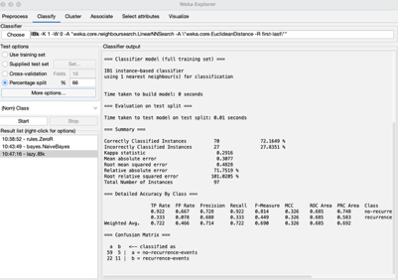
b) NaiveBayes
Accuracy: The accuracy is 71.13%

c) lazy/IBk
Values of K=4, 5, 6, and 7 give the best accuracy of 73.19%. The accuracy improves as K increases to these mid-range values, compared to K=1 which is only 72.16%.

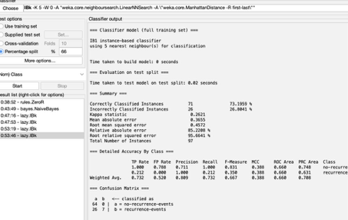
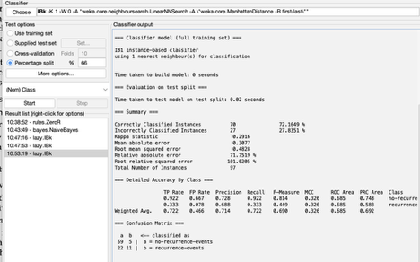
d) ManhattanDistance
K=1,8 : 72.16% / K=4,5,6,7 : 73.20% / K=2 : 69.07% / K=3,9,10 : 70.10%

Explain
The results are nearly identical, with only a negligible 0.01% difference for K=4-7. This is because Nominal/Binary attributes dominate the dataset. For such data, the squared difference (Euclidean) and absolute difference (Manhattan) are mathematically equivalent (1^2 = |1|), leading to the same neighbour selection and classification accuracy."

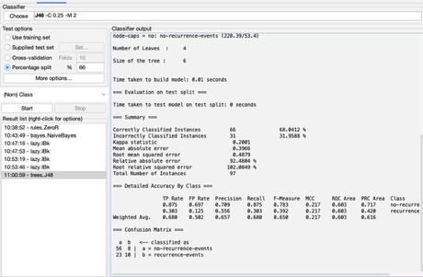
e) J48
Accuracy: The accuracy is 68.04%
Explain
The root node is node-caps.Rule: If node-caps is 'no', the model predicts 'no-recurrence-events' immediately.If node-caps is 'yes', it branches further (you would need to visualize the tree to see the exact next step, usually checking deg-malig).
The model is likely NOT overfitting. The tree is very small and simple (only 4 leaves). Overfitting usually results in a very large, complex tree that memorizes the training data. The accuracy (68%) is only slightly better than the baseline ZeroR (66%), which suggests the model is actually quite weak (potentially underfitting) rather than overfitting.

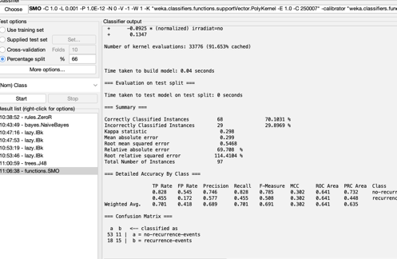
f) SMO
The accuracy of SMO (SVM) classifier is found to be 70.10% which is greater than that of J48 in decision tree at 68.04%.
Explain
The highest absolute weight of the attribute is the most influence in the model SVM: In SVM, largest weight with respect to the magnitude (usually deg-malig or node-caps of output list) is heavier contributed factor.
While J48 depends on a single attribute (node-caps) as the root to split data, SVM does so based on a weighted sum of all attributes.
The superior performance of the SVM indicates that using a weighted sum is better suited for this dataset than the simple hierarchical rules used by the decision tree.
Classifier | False Positive Rate | Precision
NavieBayes | 0.515 | 0.757
SMO | 0.545 | 0.746
IBK (k=1) | 0.667 | 0.728
J48 | 0.697 | 0.709
ZeroR | 1.000 | 0.660

Q3 Relationship between the whole weight and diameter
The NaiveBayes classifier has the lowest False Positive rate (0.515) for the no-recurrence class.It has the highest Precision for this class too with 0.757.
In this medical application, one can imagine that a False Positive for the “no-recurrence” class is deadly as it tells people with real recurrence of cancer that they are safe.
There is a potential lack of treatment if over 50% of cases are missed and this would be the case at a rate of 0.515.
Hence, even though NaiveBayes does the best, it's these rates are not acceptable to use for a real-world application of forecasting breast cancer recurrence because patient safety is at serious risk.

Q4 Predict a class with multiple values.

a) Look over the number of occurrences of each attribute value
The number of training examples for each value is equal (uniform distribution). For example, in the buy attribute, all values present exactly 432 times.

Explain
The reason for this is that the data set used is synthetic (artificial) and so it includes a dense coverage of the entire state space. It has precisely one example at each of the combination of attribute values possible (Total combinations =4 x 4 x 4 x 3 x 3 x 3 =1728) as opposed to being a random sample from the real world.

b) Using Whole weight only
Results
SMO (SVM): 93.37% / J48 (Decision Tree): 90.99% / IBk (KNN, K=1): 90.65%/ /NaiveBayes: 87.59%
Best Accuracy
The SMO classifier gives the best accuracy at 93.37%, outperforming both J48 (90.99%) and IBk (90.65%).
Parameter Setting
For IBk: Setting K=1 works best (90.65%). This indicates the dataset is "dense" and deterministic—instances with identical attributes always belong to the same class, so the single nearest neighbour is a reliable predictor.
For SMO: The default Polynomial Kernel successfully mapped the data to a higher-dimensional space, enabling it to find clearer hyperplanes that better separate the complex class boundaries (especially between 'acc' and 'unacc') than the other models.
While SMO provided the highest accuracy, J48 is conceptually the best fit because the dataset is generated from logical "If-Then" rules, which decision trees naturally model. Naïve Bayes performed the worst (87.59%) because it assumes attributes are independent, whereas this dataset exhibits strong attribute dependencies.
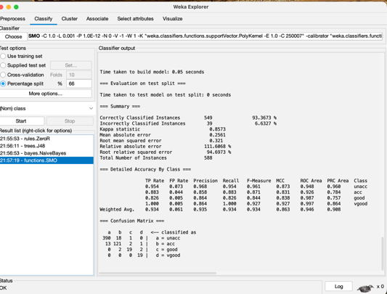
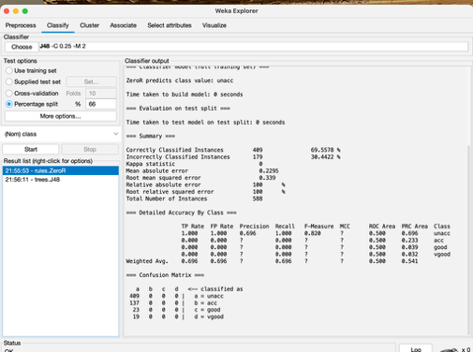
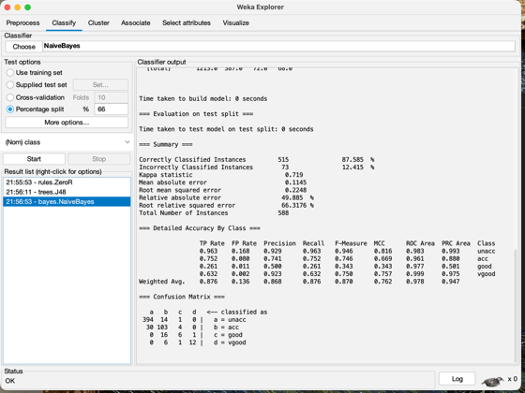

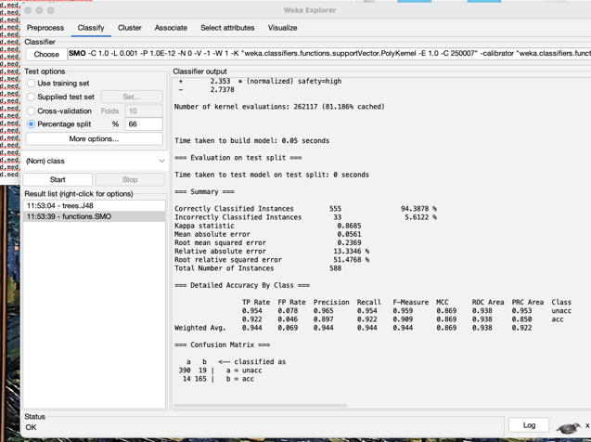
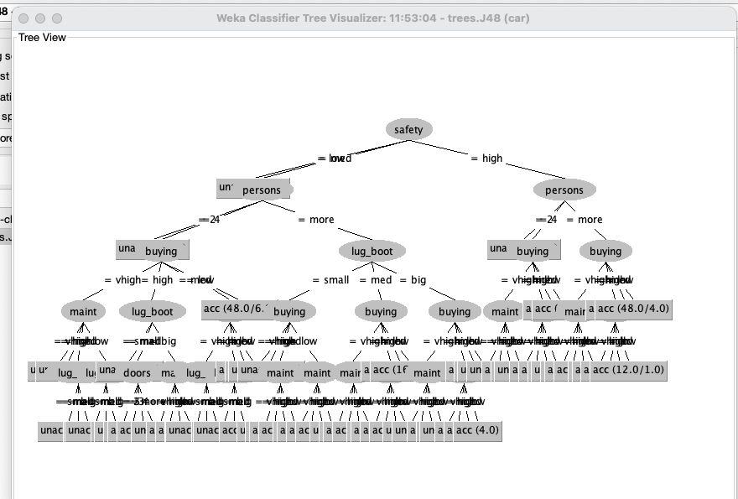
Q5 Modify the data to binary classification

a) Attribute values
According to the only structured decision tree J48, wetypes have analyzed, there are two particular attributevalues with which a vehicle is automatically and unconditionally classified as unacceptable (unacc): safety = low / persons = 2
Detailed Explanation
Evidence from the Tree Structure:
The decision tree itself tells us that safety is the most important attribute, as it appears at the top of the tree. The branch for safety = low goes to the single leaf node unacc. That is, when the safety of a car goes down very low it will be refuse to purchase regardless price, maintenance cost or other attributes.
The Second “Deal-Breaker”:
If the safety is not low (i.e., it is med or high), then in the next step, the tree splits on the persons attribute. In either of these cases, if the value is persons = 2, there's a path to an unacc leaf node.
Conclusion
Unlike other attributes (buying or maint) for which you need to look at multiple conditions to work out the class, safety = low and persons = 2 is enough by itself to declare a car unacceptable. This follows a prioritization scheme, which makes sense insofar as safety and pas
b) J48 V.S SVM
The J48 Decision Tree model is much more interpretable the SVM model.
Justification
Visual Logic (J48):
A clear and hierarchical flow chart can be generated by the J48 model.It replicates human reasoning through simple “If-Then” rules.
Example (Referring to the tree):
Anyone can easily answer: "Is safety low? Yes -> Unacceptable."
The form also has place to follow the journey and see prioritisation so you can see what attribute is more important (Safety -> Persons -> Buying, etc.) and how different attributes relates to each other for a final decision.
"Black Box" Nature (SVM):
Model #I is the SVM (SMO) model which is very accurate, albeit complex in terms of toss compiling a mathematical formula (94.39%). It returns a list of weights (coefficients) like + 2.353 * (normalized) safety=high. In order to anticipate this, one has to compute a weighted sum of all attributes. This is intangible and requires a bit more of an effort for the human to understand/recognize compared to your decision tree. It gives you what of the mathematical importance, not why in a narrative manner one decision was made.
Conclusion
Both models are strong, but the J48 is the more useful model when stakeholders (everyone from my 5yr old asking “-but why did it say ’no’ mommy”) want to hear an explanation of why a decision was made.

